Michele Speidel

6/19/2022

Module 4.2 Assignment

MongoDB Atlas Setup (also includes visual studio setup)

CSD310-330H_2225_DD

Database Development and Use

VS Code Install

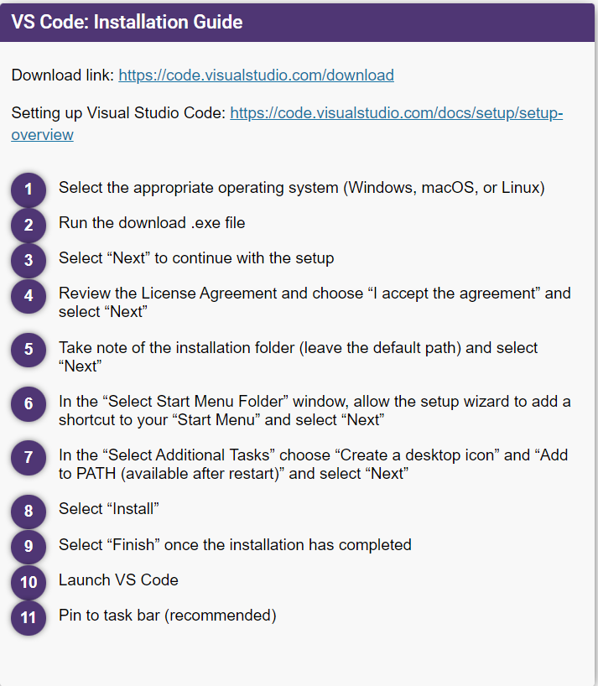

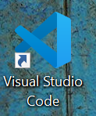

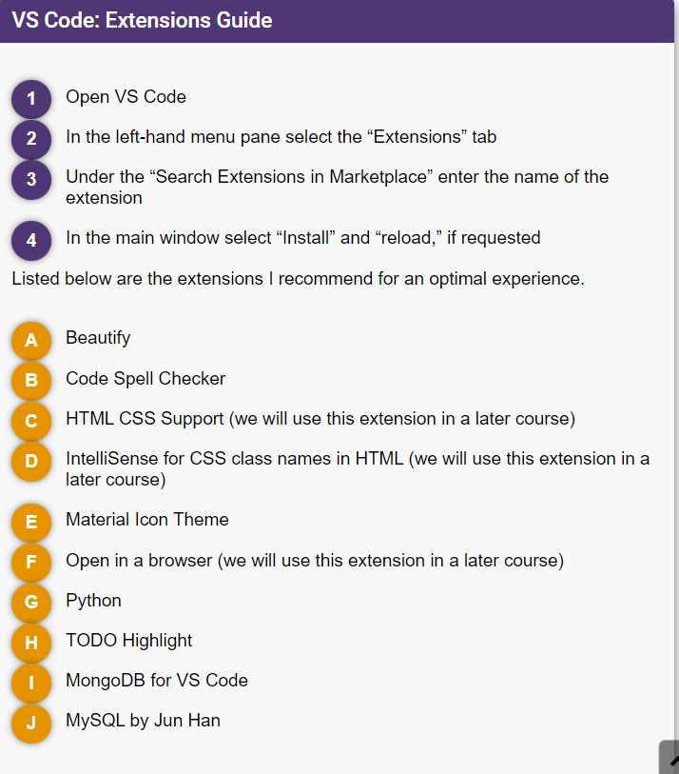

A.Beautify

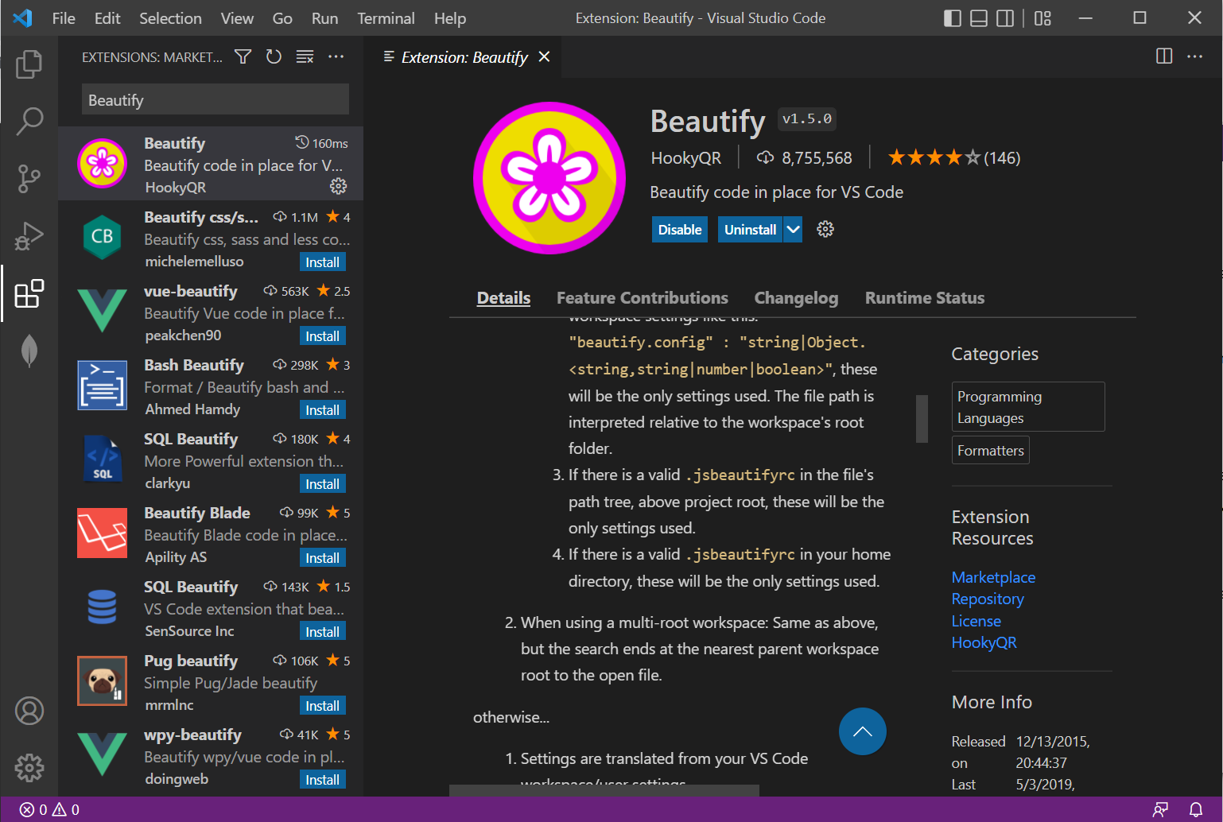

B.Code Spell Checker

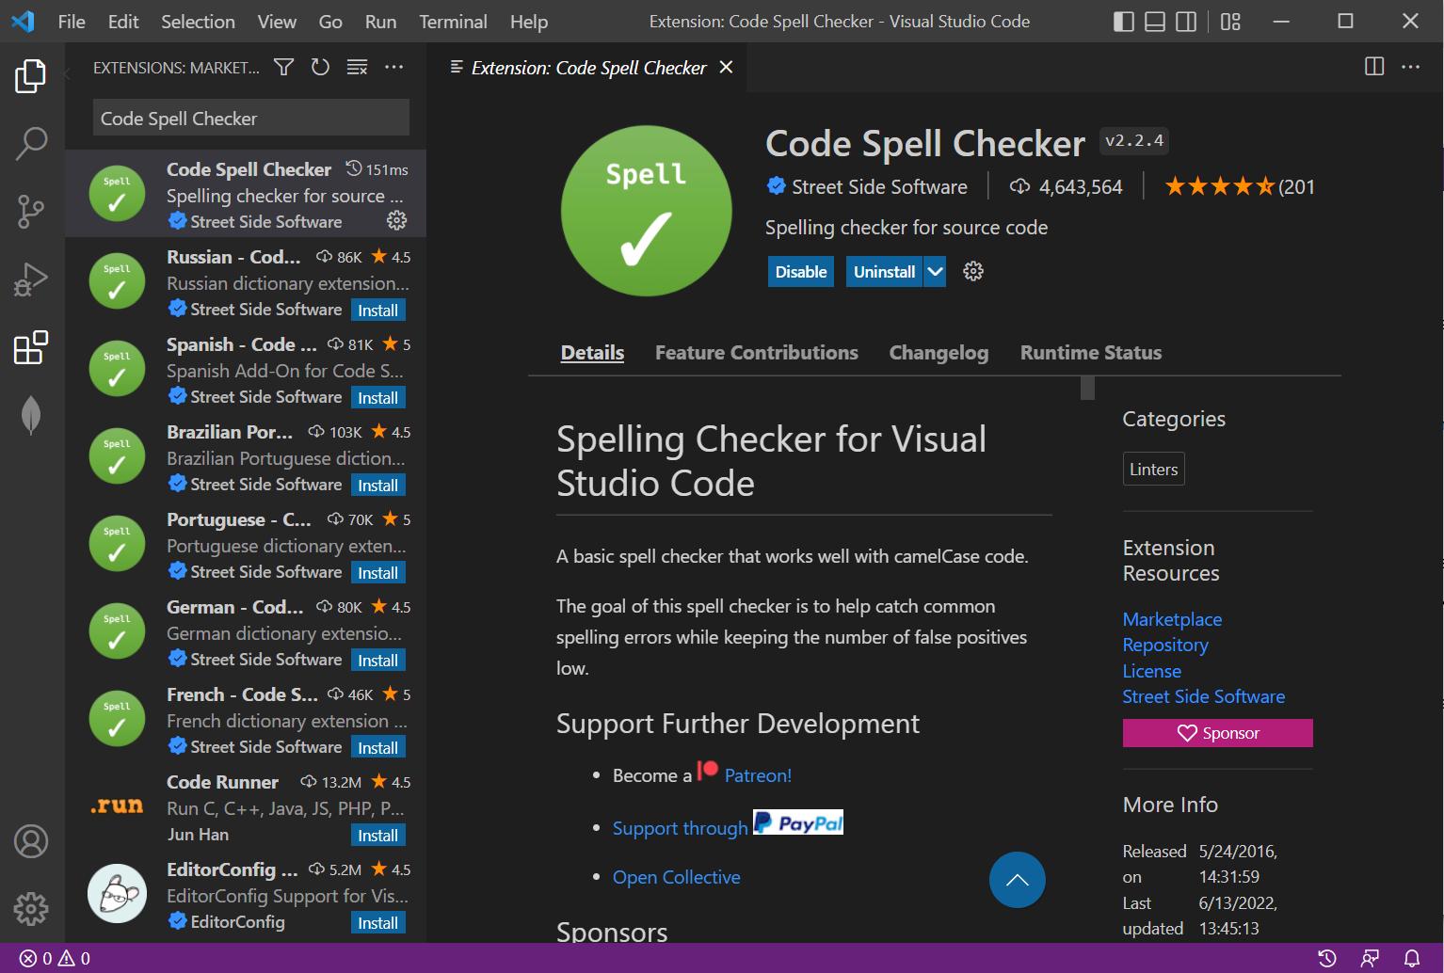

C.HTML CSS Support

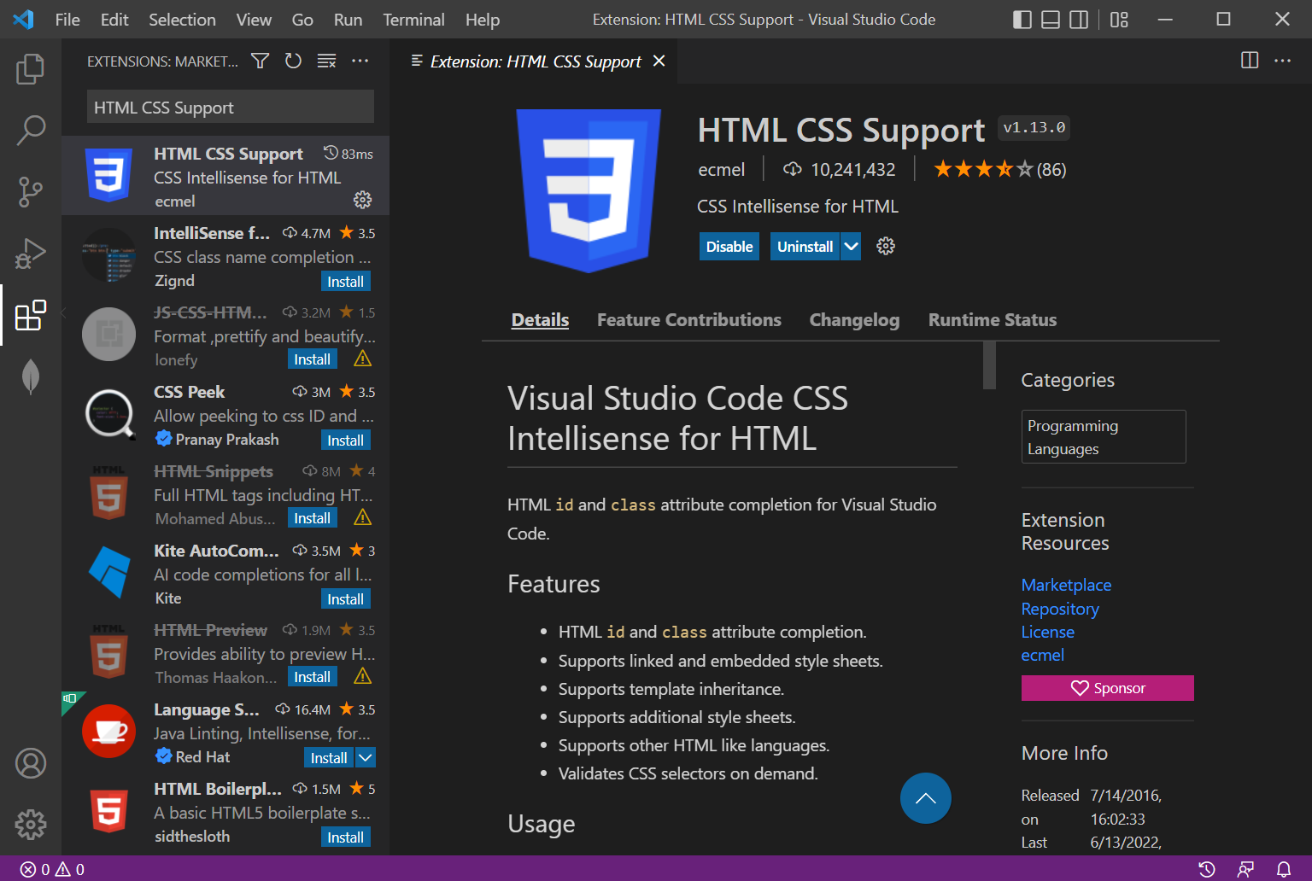

D.IntelliSense for CSS Class Names in HTML

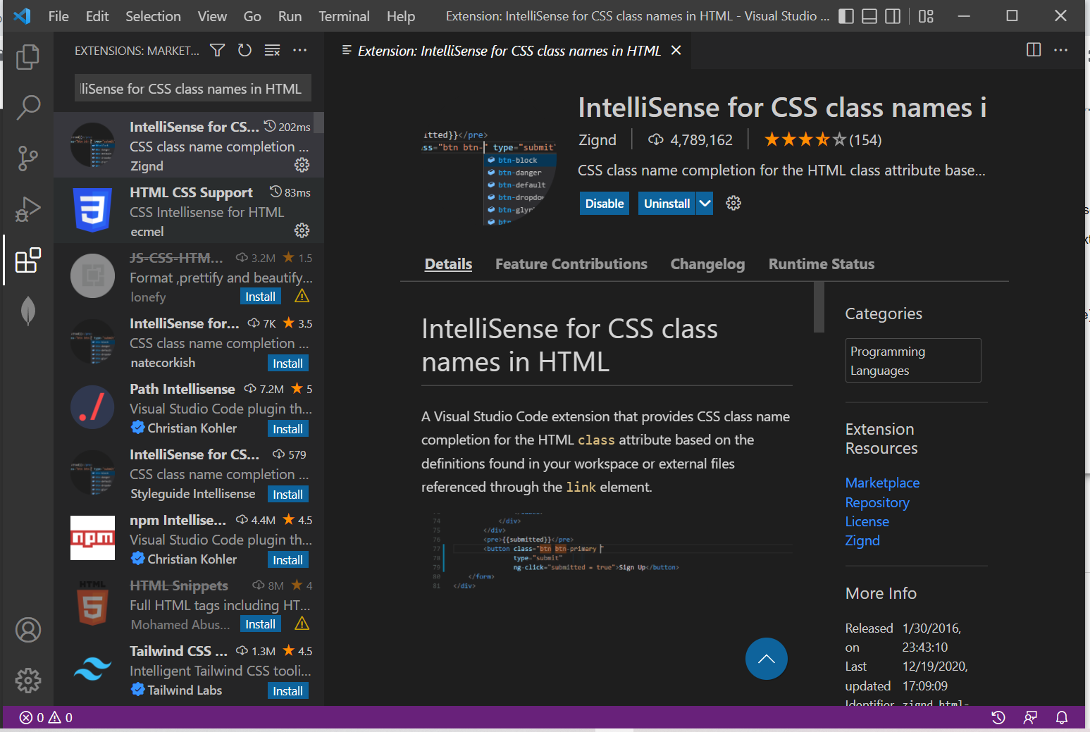

E.Material Icon Theme

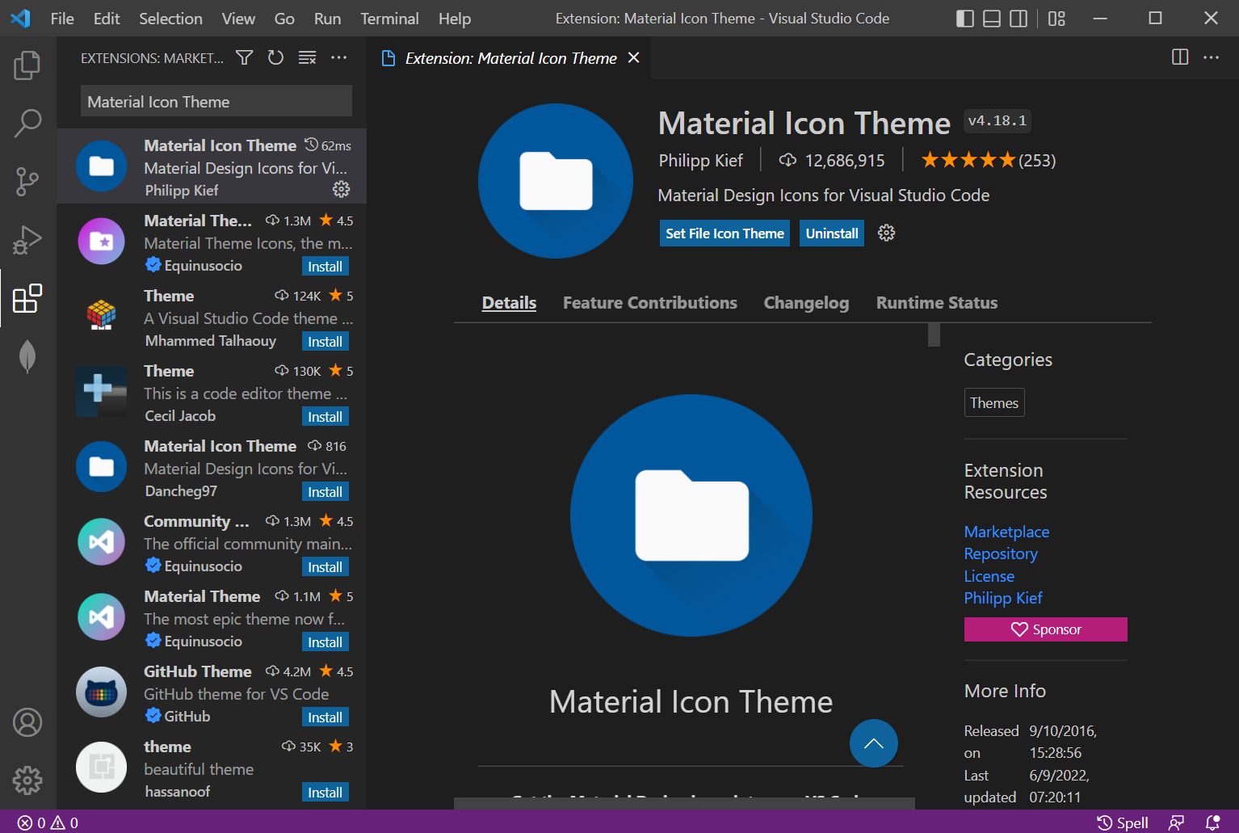

F.Open in a Browser

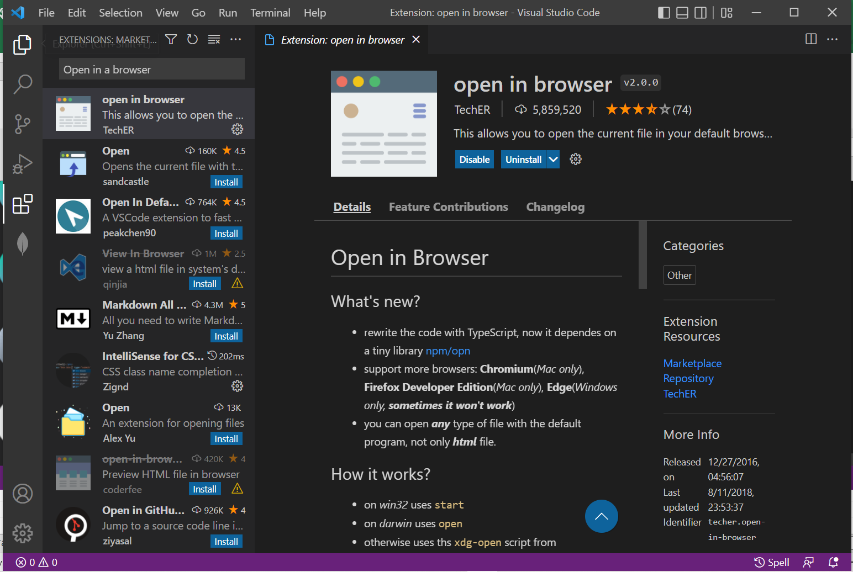

G.Python

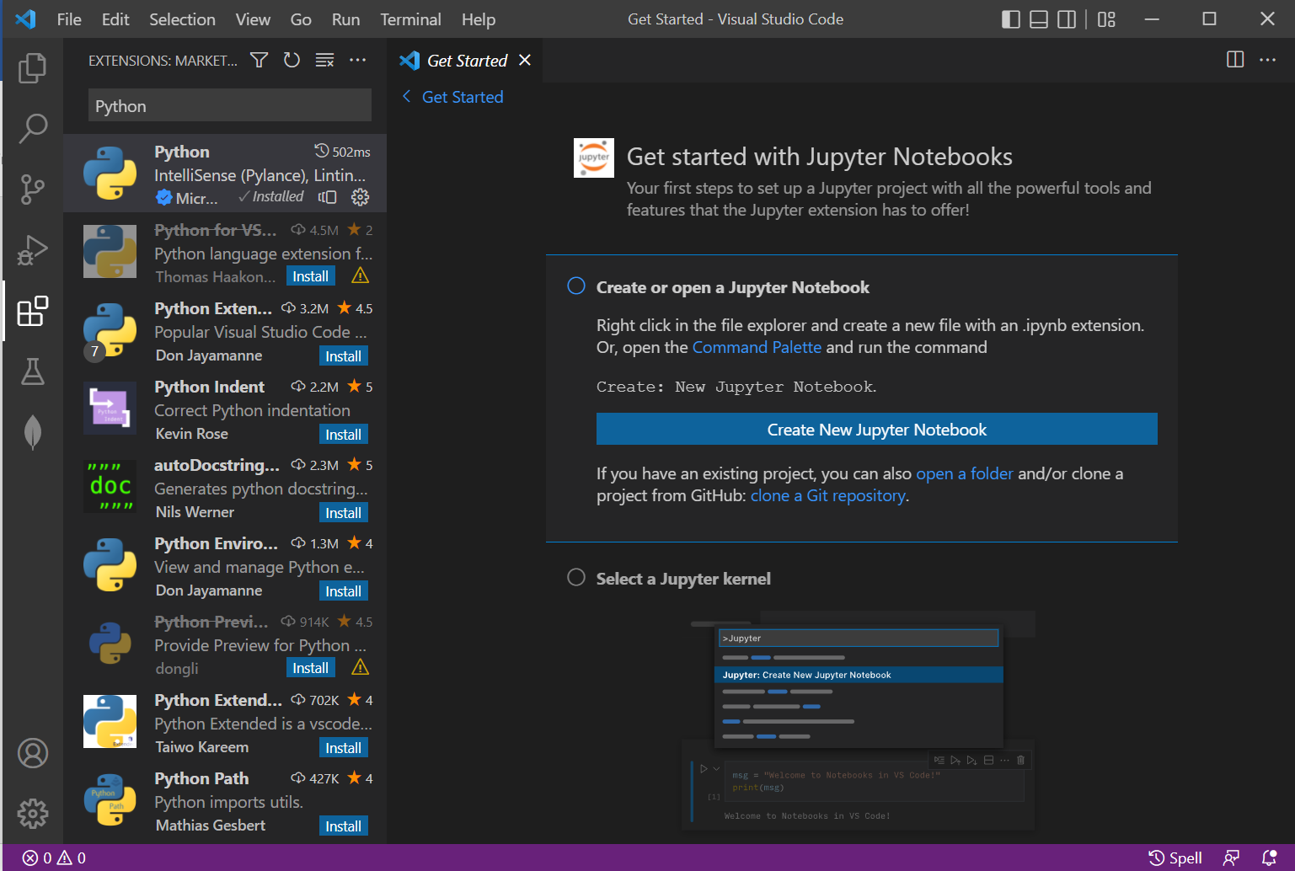

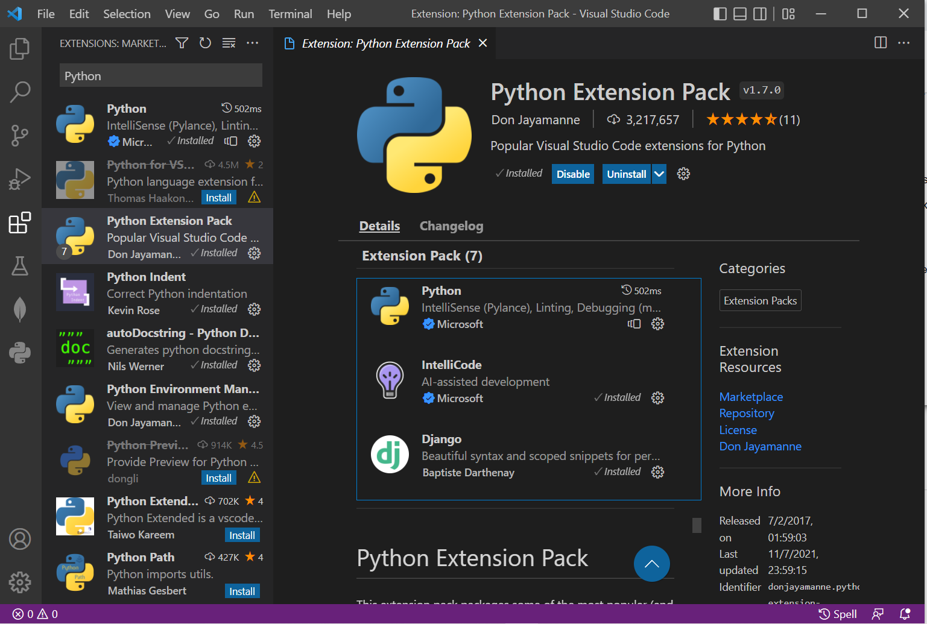

H.TODO Highlight

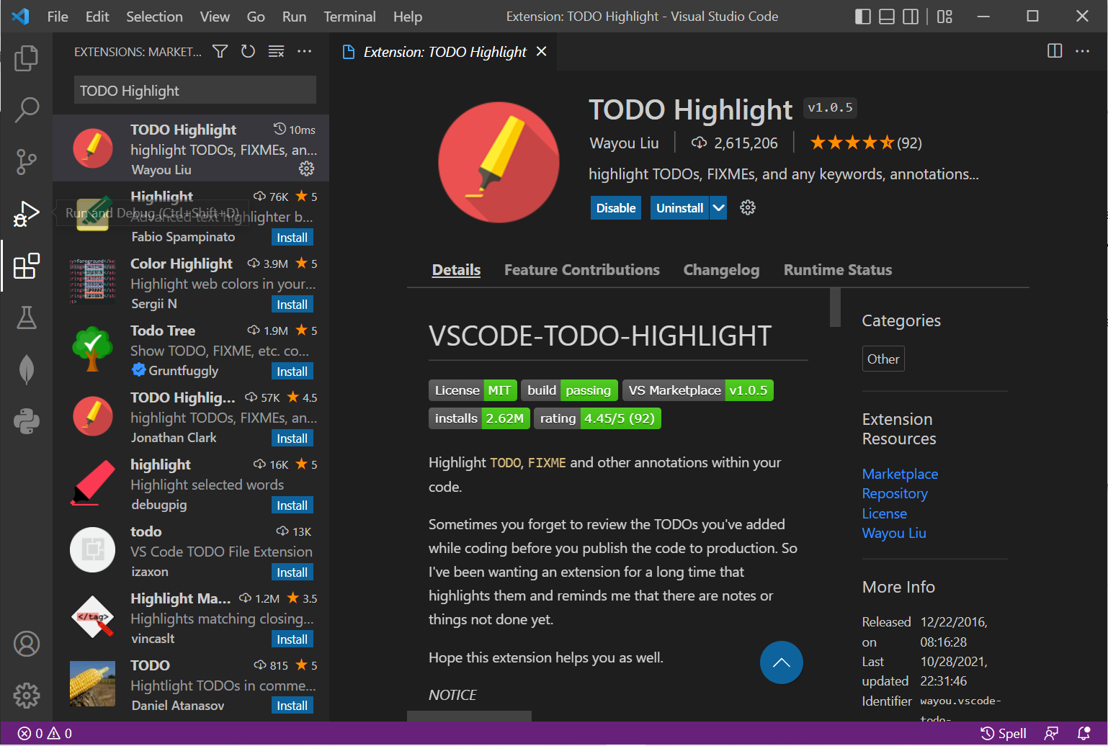

I.MongoDB for VS Code – Visual Studio Code

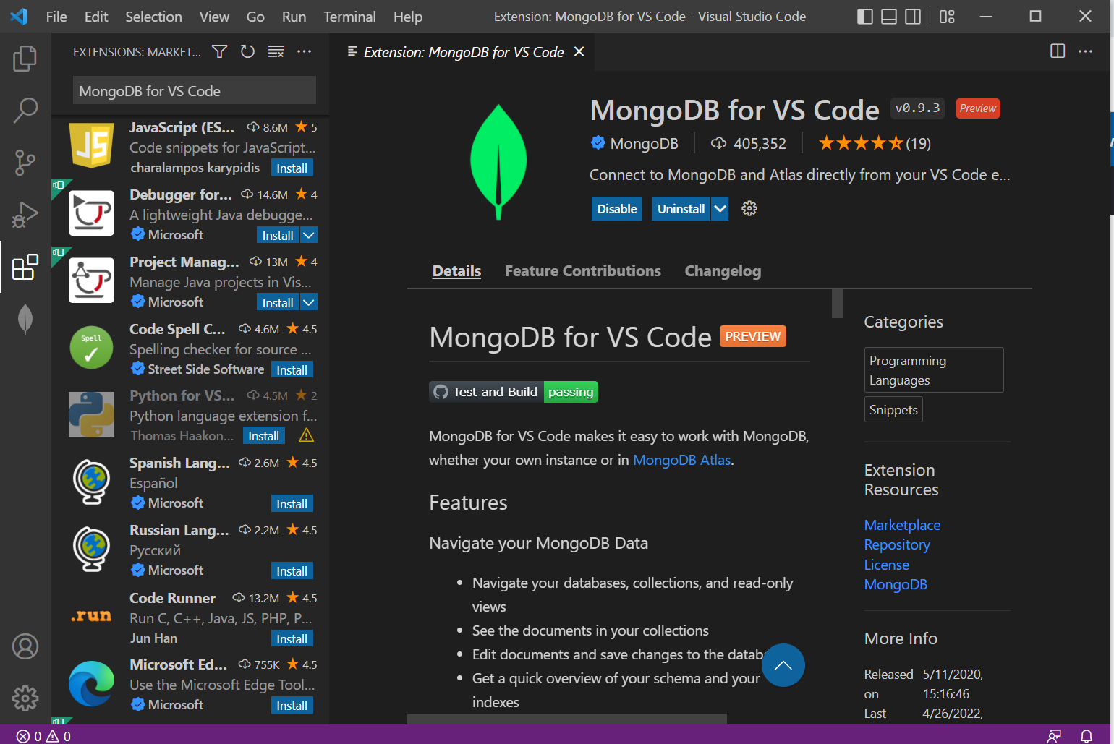

J.MySQL by Jun Han

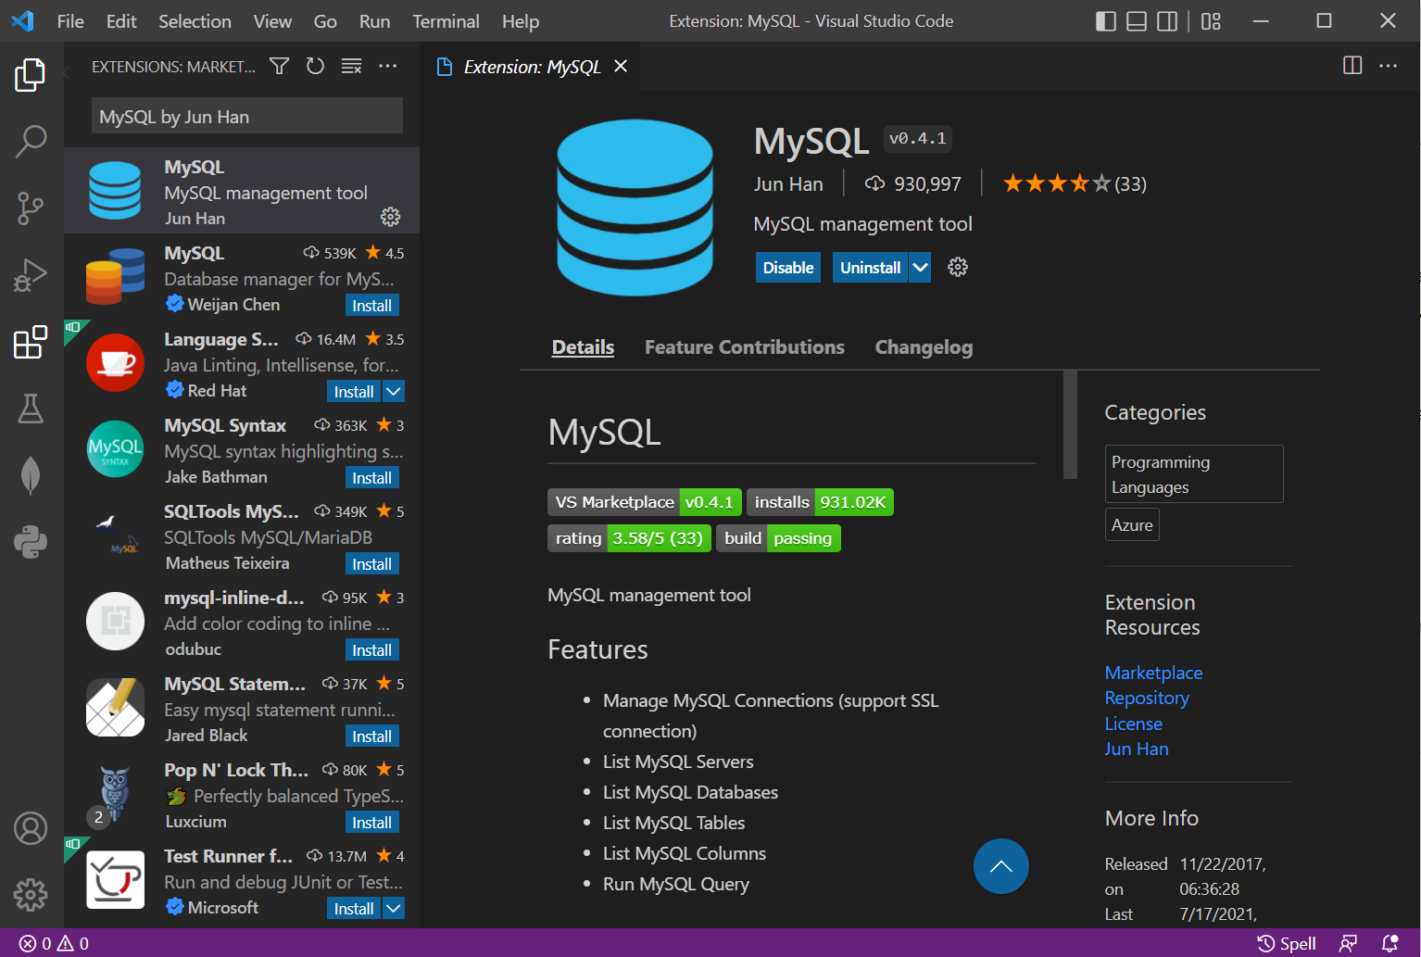

1.MongoDB Atlas Setup

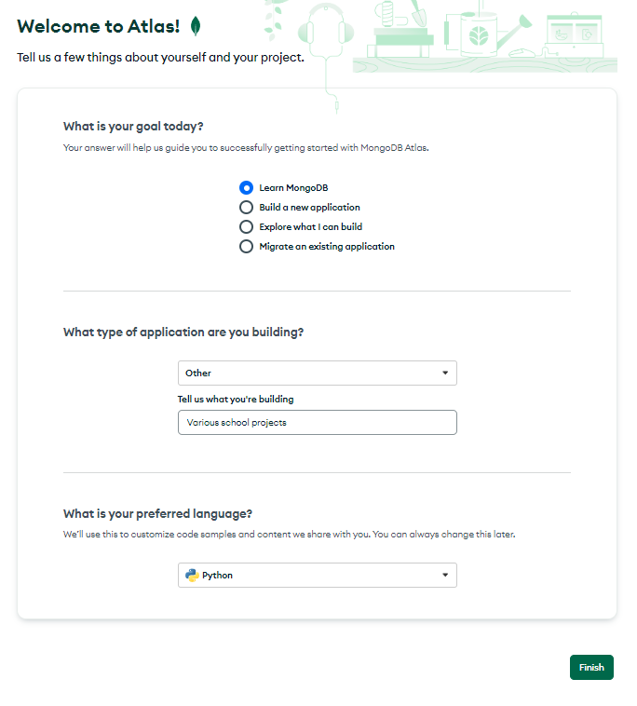

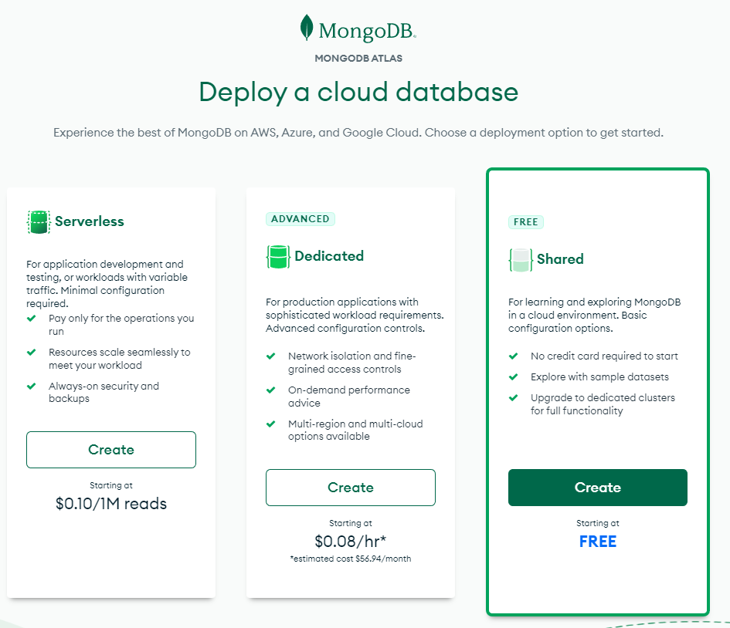

2.MongoDB Cluster Setup

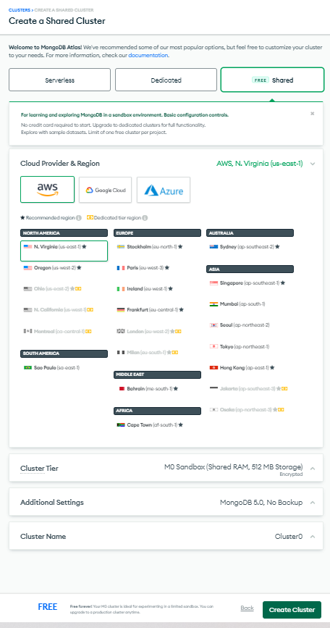

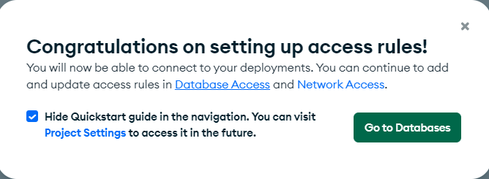

3.Organization/Project Setup

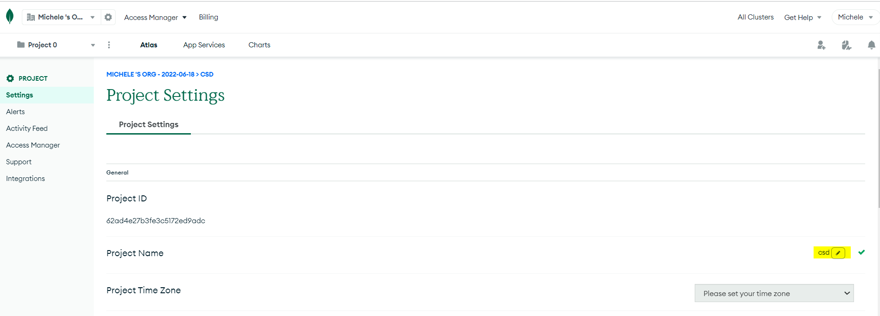

4.Secuirty Provision

I was prompted to set up securities during step 1. I set up a 2nd user as user name “admin” and password “admin” based on set 4 instruction. Let me know if I should delete my 1st user name and password.

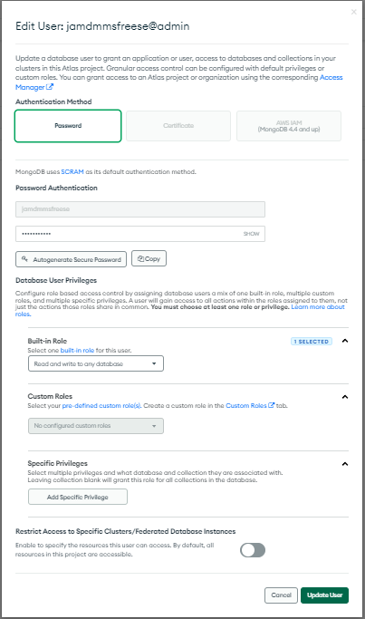

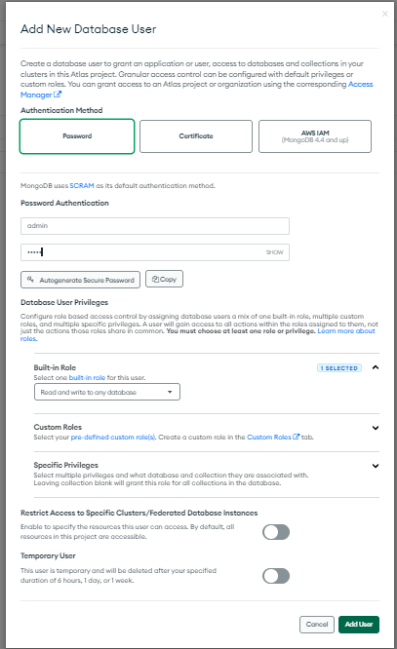

admin/admin

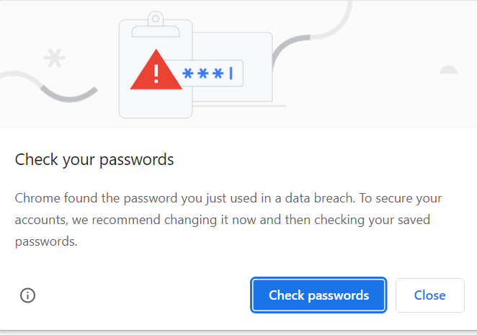

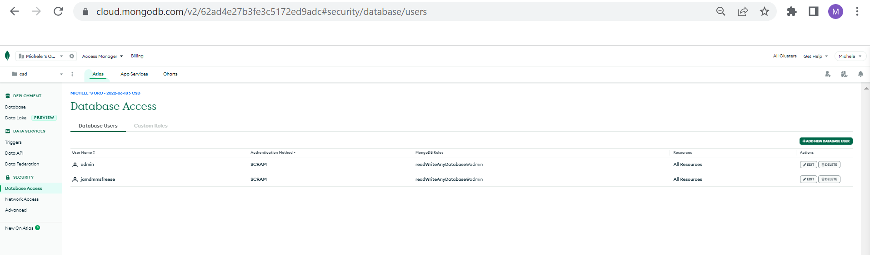

5.Whitelist IP Addresses

I did not see a “Whitelist IP Address” tab. I did have an “IP Access List”. That is where I set up the IP number. I also set up an IP address using my own computer. Should I remove that one?

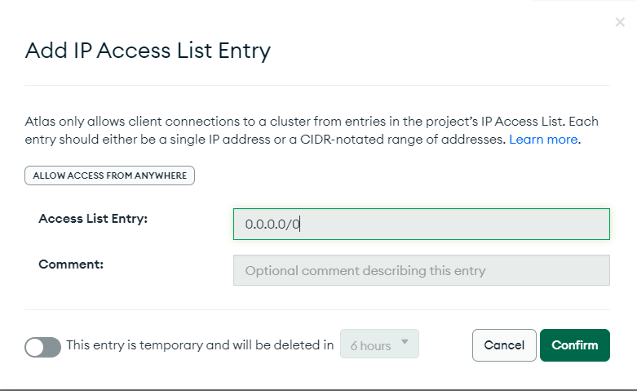

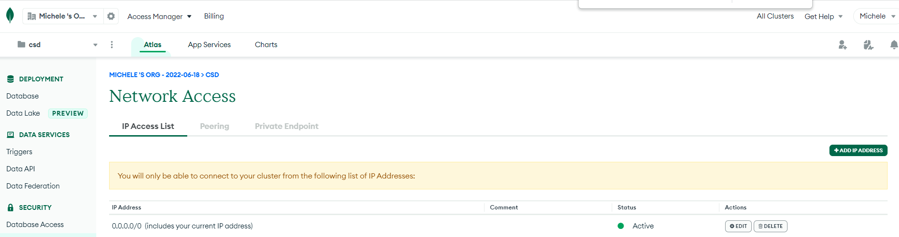

6.Access the Cluster

